End of life planning for Veterans

The project that I chose to pursue would be end of life (EOL) planning for military Veterans. During my time in the Marine Corps, I encountered many situations where family members needed to take care of a loved one’s legacy. The Department of Veteran’s Affairs has measures to mitigate the burden and sorrow on family members with their forms to ensure the Veteran’s legacy is preserved. What I noticed that there were very clear and easy to use instructions for smartphone users, but I have yet to see a flip-phone interface. With the FCC Lifeline program, flip phones are available to low-income consumers and they have an internet connection, so it is possible to have an application that they are able to use, just with refinements to accommodate the hardware limitations.

RESEARCH

Several Veterans were interviewed to take an understanding on their views for EOL planning. Overall, they weren’t aware of the forms that they could fill out to ensure their families received proper benefits. Nearly all interviewees didn’t know about the applicable forms, yet were intrigued to have their benefits claimed.

Another research method was to look at different programs that were less known. During my time with the Federal Government, I noticed that there were a lot of Veterans that didn’t know about pre-need forms. As I showed them how to do the forms, they in turn wen to their parents and grandparents to assist them with completing the necessary forms. My own experience with others not knowing was something that I wanted to help solve in moving forward.

The improvements are immeasurable because there is no known existence of a flip-phone application for Veterans to use. Having one will assist those with flip-phones to request their benefits in a manner similar to smartphone users can.

SKETCHES

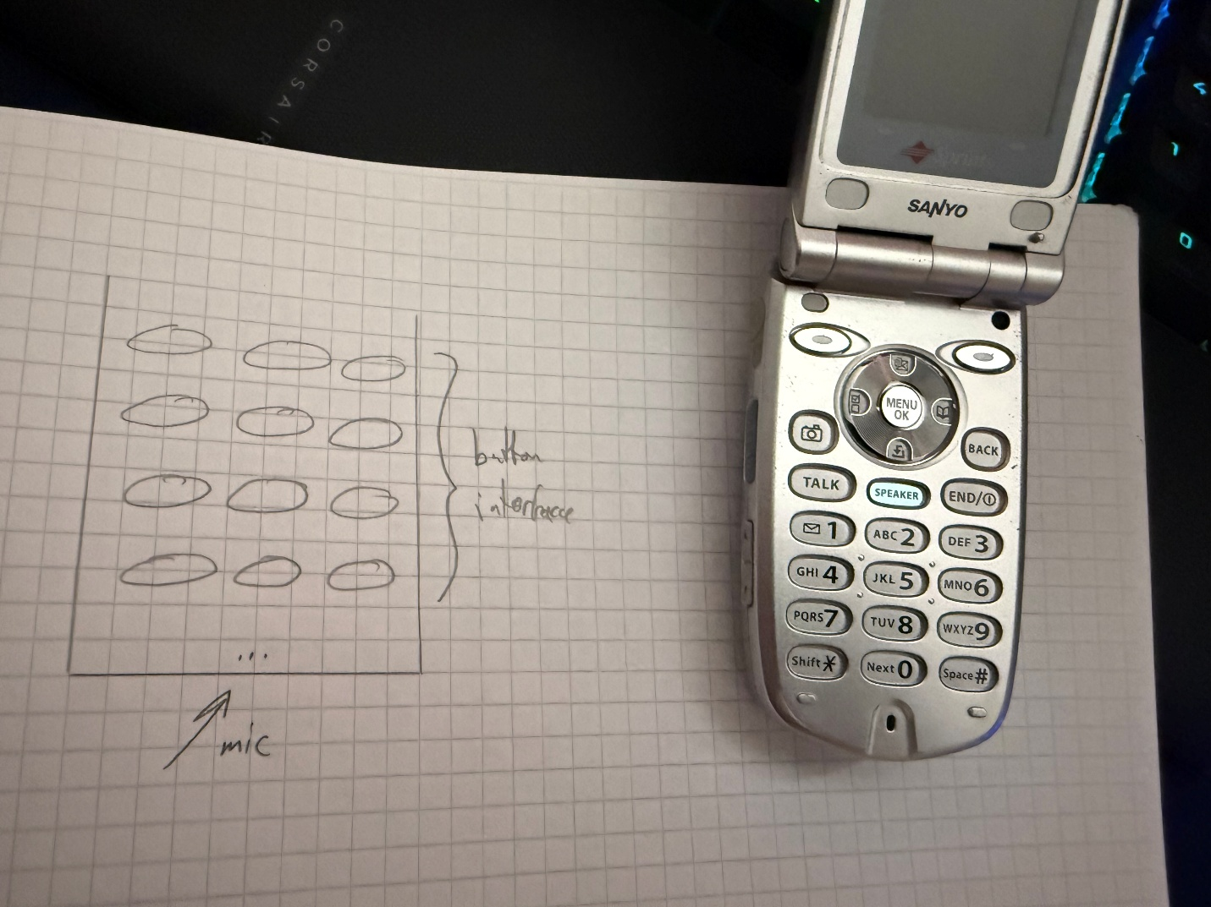

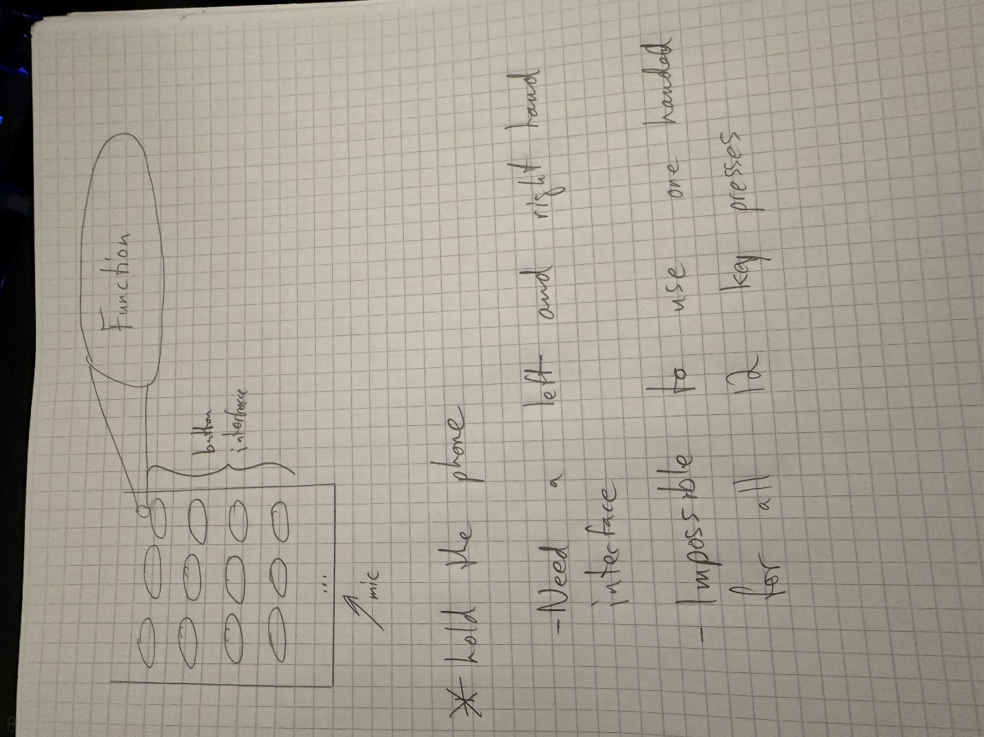

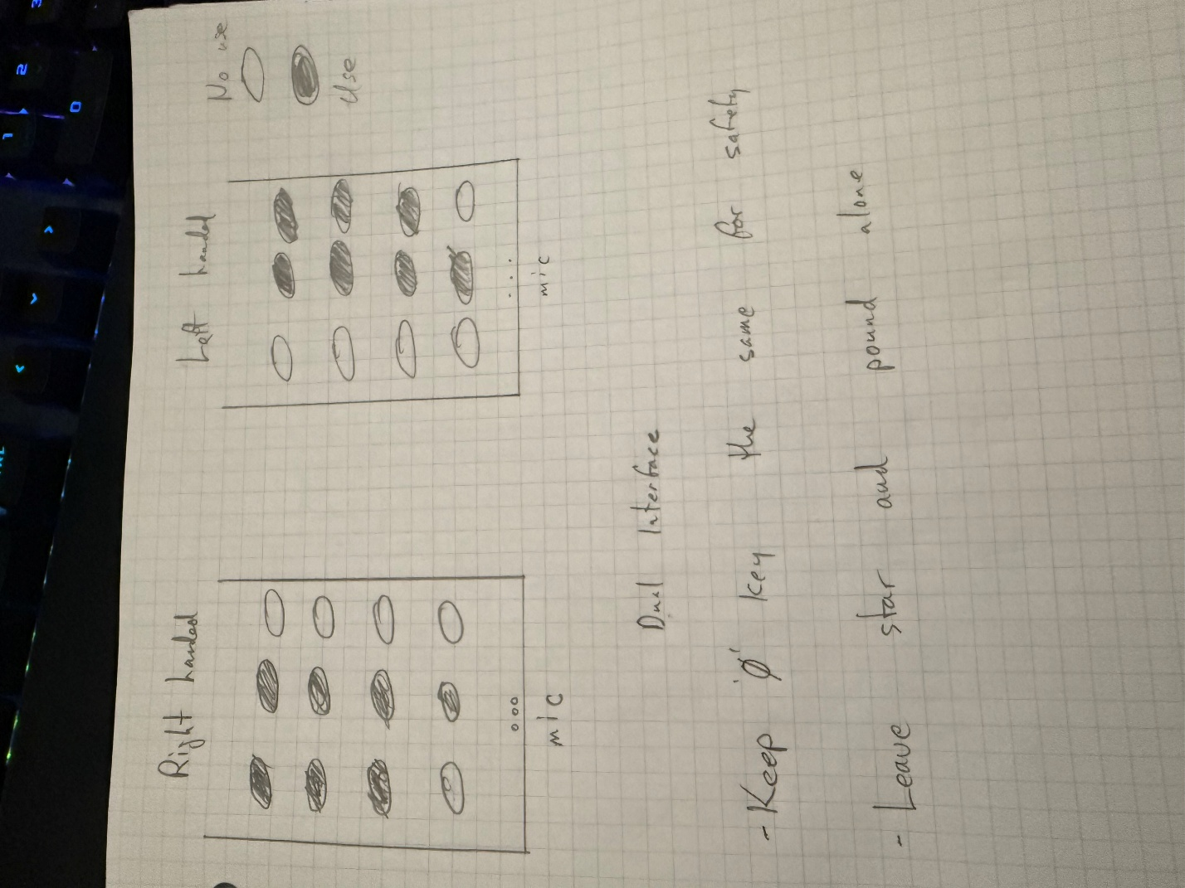

User Feedback

Once users used the 3D printed interface to interact with the flip phone, they realized that there were different approaches needed to fulfill a total interface interaction. Users were pleased with the flip-phone interface, as it was easy to use and got right to the point. The Lord of the Rings was a great touch and surprisingly accurate for the waiting length of time. One suggestion was to use the extended versions to fill in the time the original trilogy didn’t fill.

